**Guide to the structure of the environment section pages.**

**Notes**

This page is to show how the web section is structured, to help council members and the web writer understand the proposed structure.

It is not needed on the actual website.

Please review the content and either email me with comments or bring written notes to the next council meeting.

Opening Page

Supporting Pages

# **Vision for a more environmentally responsible future for our parish**

Landing Page

# **Context**

Regardless of our views of the causes, climate change is now happening, and the consequences are inevitable to some extent. Our vision in the Ramsbury and Axford Parish is to do our bit to improve our local practices and make our natural environment better for the people and wildlife in our community, including trying to reduce any negative impact on our evolving climate.

As a parish council we can be a small force for change in addressing the climate and nature emergency, our vision needs to drive practical but impactful change locally.

# **Our vision**

Ramsbury and Axford parish council aims to support the drive to a more sustainable climate and an improved local environment through steering efficient environmental practices across our community and those involved with events and businesses in the parish. We will encourage better biodiversity and clean places for our community to live, work and play in, ensuring these actions will not have a negative environmental impact in and beyond the parish where possible.

# **Aims**

Our parish aims to continue to evolve our local ways of working where we have any influence by putting in place clear practical guidance around three core areas:

1. **Environment**: The parish council will strive to support local ideas and initiatives to improve the village, its wildlife spaces, biodiversity or further reduce our climate impact
2. **Resources**: Our community, local businesses, and contractors engaged in activities in our parish will be encouraged to be more carbon neutral, employing the principles of the **4R’s: reduce, re-use, repair and recycle**
3. **Operations**: Parish council operations, processes and use of buildings and equipment adopt more resource efficient practices

# Details and Information for Each Area

Details/Support Pages

](#_Enhanced_Environment)

***Enhancing Our Environment***

**](#_Rational_Resources)**

***Rational Resources and Recycling***

**](#_Optimised_Operations)**

***Parish council Operations***

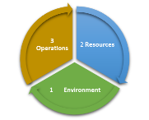

***Suggestion Box***

# **Enhanced Environment -**

Details/Support Pages

|  |  |  |
| --- | --- | --- |
|  | Description | Parish actions and guidance |
| Enhanced Environment | Focuses on our local nature and wild places, striving to build upon the excellent work already done in the Parish. | The parish council are supporting ongoing initiatives including dog waste bag dispensers. The bags we provide are biodegradable, albeit over some time, but we will always consider suitable alternatives. Until then, please dispose of these in waste bins provided around the parish  The parish council will assess and support future ideas suggested by the community to improve the wildlife spaces and biodiversity in our parish *– see map below illustrating the parish boundaries and where we invite suggestions for improvements* |

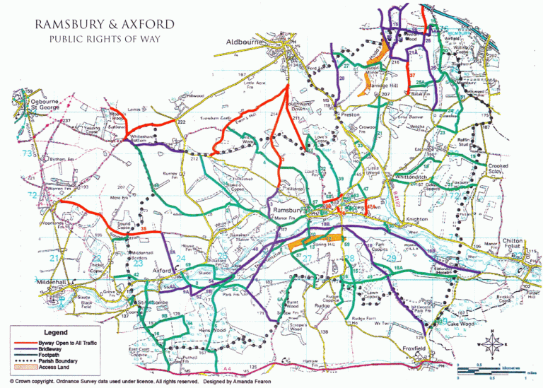

Kennet River, Axford. ©B.Murray 2023

](#_Details_and_Information)

**Rational Resources**

Details/Support Pages

|  |  |  |
| --- | --- | --- |
|  | Description | Parish actions and guidance |
| A diagram of a pie chart  Description automatically generatedRational Resources | Resource use across our community, by local businesses, and services in the parish. | The parish council is encouraging local businesses and services to reduce the use of single use plastics.  The parish council will direct residents to existing support and guidance. In addition, we will invite and then pro-actively review local resident recommendations for the better use of resources and support these when agreed by the council. (See locally written article on the Spotlight on the 4Rs) |

There are a number of opportunities to support the parish council aim to adopt the 4R’s: (reduce, re-use, repair and recycle). These include using the Marlborough Recycling Centre which recycles a wide range of items including some picked up at the roadside (plastics, glass, batteries, card, paper), see link for up to date guidance; <https://www.wiltshire.gov.uk/rubbish-and-recycling> . The WRAP recycle website can be used to find out what is recyclable in our area; <https://www.recyclenow.com/>

|  |  |  |  |  |
| --- | --- | --- | --- | --- |
| **Specific support** | **Repair** | **Re-use** | **Recycle** | **Details** |
| Blister packs, inhalers, and unused medicine |  |  | **🗸** | **Ramsbury surgery** accept medical blister packs, inhaler canisters and unused medicines. Collection points are in the foyer and at the pharmacy |
| Cosmetics |  | **🗸** | **🗸** | **Boots** (check locations on the Boots website) will accept cosmetics and offer incentives for their return: <https://boots.scan2recycle.com> |
| Clothing recycling |  | **🗸** | **🗸** | **Outside the fire station and Whittonditch Road playing area;** items should be clean and in sealed tied bags |
| Garden tool sharpening | **🗸** |  |  | **Ramsbury Horticultural Society** will provide this service at society events |
| Unwanted household items,  jewellery, toys, and books |  | **🗸** |  | **Ramsbury Charity Shop -** no clothing items please, other items in good  condition |

# Useful websites

|  |  |
| --- | --- |
| <https://www.wiltshire.gov.uk/rubbish-and-recycling> local recycling  <https://www.recyclenow.com/> further tips and info on recycling  <https://www.reducereuserecycle.co.uk/greenarticles/where_can_i_recycle.php>  fairly comprehensive list of what and how to recycle | <https://boots.scan2recycle.com> for recycling of beauty products  <https://www.podback.org/> for recycling coffee pods  <https://lionsclubs.co/MemberArea/home/spectacles-recycling/> to repurpose spectacles (Specsavers, Boots, Peep Eyewear will recycle)  <https://www.packagingnotincluded.co.uk/> refill shop in Marlborough |

](#_Details_and_Information)

# **Optimised Operations**

Details/Support Pages

|  |  |  |
| --- | --- | --- |
|  | Description | Parish actions and guidance |
| A diagram of operations and resources  Description automatically generatedOptimised Operations | How the parish council carries out its duties in the area. | 1. Communications across the parish will be electronic where possible, and the Council will publish on-line articles, host talks and hold events (could be online or in person). 2. Council supported events on parish land.   *At village events, contractors will be expected to submit details of how they propose to* ***minimise their carbon footprint****, including but not limited to removing single use plastics.*   1. The management and maintenance of parish owned buildings will aim to minimise negative impacts on our environment. |

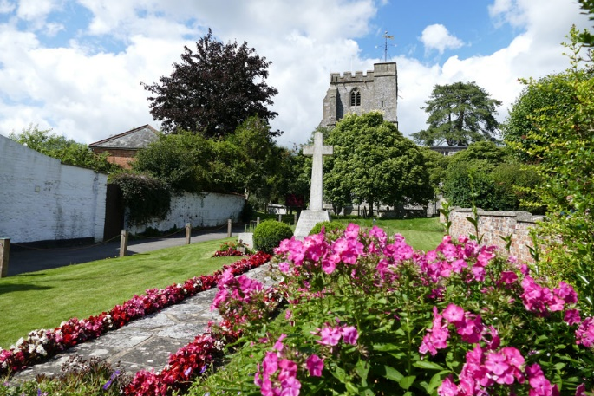

Best kept village activities. Ramsbury has won the best kept large village seven times, the last was in 2021 (:www.Ramsbury.org)

](#_Details_and_Information)

Suggestion Box Page

# **Suggestion Box**

**We welcome suggestions from across our community, including businesses and services for initiatives that might enhance or improve parish council operations, resources utilisation or our environment. Suggestions from our community can be sent by email to** [**parishcouncil@ramsbury.org**](mailto:parishcouncil@ramsbury.org)



](#_Details_and_Information)

Relevant Article(s)

# **SPOTLIGHT on Reduce, Reuse, Repair, Recycle! *By Dawn Gill***

There is a lot of talk these days about how reducing, reusing, repairing, and recycling various household items can help us all to be more environmentally friendly, to be greener, to be ecologically sound and live sustainably. These four terms all refer to ways that we can minimise the number of materials that we use, the amount of the Earth’s resources that we use, the energy that we use and the amount of waste which we produce in our everyday life. But how do we do this? Here is some information which we hope will help the residents of Ramsbury and Axford on their journey towards being more sustainable.



Reduce

**Don’t create waste if you don’t have to**

Reduce is first on the list because it is the simplest and most important way of minimising your impact on the Earth’s environment. It means that you try to reduce the number of materials that you use and the resources such as fuel and water that you use or are used in the delivery process of such items.

Here are some examples of ways that you can reduce: -

* By not buying items that you do not need, for example only replacing items when they can no longer be used or are beyond repair.
* Buy refills – they take up much less room and so fewer delivery lorries are needed, therefore reducing carbon emissions as well as plastic waste.
* Save up to thousands of bottles and cans per year and take your refillable bottles to refill shops instead of buying single-use household containers.
* Buy your own reusable drinks bottles.
* Take your own bags to shops and say NO to paper AND plastic.
* Refuse to buy items that have excessive packaging, for example chocolates that come in plastic boxes or items that are sold in an unnecessarily large container.
* If you need to print out a document, print on both sides of paper, and in black of white if suitable. If you have paper that you have printed on one side only, maybe use the back to write on.
* Choose to walk, cycle or take public transport rather than using a car.
* Hang washing outside to dry rather than using a tumble dryer.

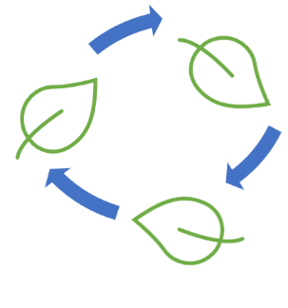

Reuse

**Reuse, share, sell, or give away still usable items.**

If you have an item that you can no longer use or simply do not want, but is still in a usable condition, you should try to find a way that it can continue to be used rather than throwing it away – potentially in landfill.

Here are some examples of ways to reuse: -

* Sell the item, for example by advertising it on one of the many websites such as eBay, on Facebook groups, Nextdoor or via local newspapers. If it is an antique or collectable item, you may be able to sell it to a local antiques shop.
* Give it to a friend that needs the item.
* Donate it to a charity shop (e.g., Ramsbury Charity Shop) where it can be sold to raise money for a good cause.
* Give it to somebody who is looking for something, via websites such as Freecycle or Freegle.
* Hold a garage sale or get a pitch at a car boot sale.
* Make the item into something else completely. Often referred to as ‘upcycling’.
* If you do need to buy something, see if you can buy it second-hand, borrow it from someone else or hire the item. As a bonus you will also save money!



Repair

**Repair items before deciding to throw them away and buying new**   
Here are some examples: -

* If an item is damaged, try to repair the item rather than buying something new. Clothes and electronics are good examples of items which are often thrown out when they become damaged, yet they can often be repaired.
* Buy furniture and products that last if you can, then repair, repaint, or re-finish them to give them a new look.
* Buy/borrow a knife sharpener and revive those tired knives.
* Sharpen gardening implements - a sharpened shovel or hoe makes life so much easier, and this service is provided at our Ramsbury Horticultural Society events! (check – do they also sharpen knives and scissors?)



Recycle

**Recycling means to break down an item and to make something new from the materials.**

Some examples of recycling are: -

* Ramsbury surgery (in the foyer) accept pharmaceutical blister packs which are sent to Superdrug who send them off to be recycled into boards for the construction industry. The surgery also accepts inhaler canisters for recycling. Both these collection points are easily accessible in the surgery foyer. They will also take back unused medication at the pharmacy counter, preferably in the original packaging, to be safely disposed of.
* Textiles such as clothing and bedding which are in poor condition and cannot be used or mended, can be used to make cleaning rags, or for filling furniture.
* Wastepaper can be pulped and used to make new pieces of paper.
* Plastics can be melted down and made into new plastic items.
* Electrical items can be broken down and the metal components melted down to make a new item (this is particularly important in the recycling of irreparable mobile phones as they contain small amounts of rare and valuable metals.) The plastic casings can also be recycled.
* Glass can be melted down and made into new glass items.
* Cosmetics are accepted for recycling by Boots– <https://boots.scan2recycle.com>
* Soft plastics and wrappers (if it springs back when you crumple it) can be recycled at most supermarkets - please rinse first.
* Coffee pods can be recycled by getting a free recycling bag when you buy coffee pods – <https://www.podback.org/>
* Spectacles can be sent to eye centres in the developing world by Lions International – <https://lionsclubs.co/MemberArea/home/spectacles-recycling/>
* Tea bags – many are now sealed with a thin layer of plant-based plastic (PG tips, Yorkshire Tea, Clipper, Co-op, Asda, and Sainsbury’s own brands plus Tesco soon) and can be put into garden waste or composted.

How you dispose of an item depends on what local recycling facilities there are where you live. Please check the Wiltshire County Council website – <https://www.wiltshire.gov.uk/rubbish-and-recycling>

**Not recyclable**

* **“Compostable” or “biodegradable” plastic wrappers** were initially heralded as a revolution, but the tide is turning on these plant-based plastics. The University College London’s Big Compost Experiment published late 2022 highlighted how poorly compostable they actually are. Unfortunately, they should just go in the bin.
* **Pyrex dishes and drinking glasses** – the different melting points causes havoc with glass recycling.
* **Disposable nappies –** but trials are being run to use them as a road resurfacing material, already successful on the A487 in Wales, so it may happen!
* **Large plastic toys** – give them away if still serviceable, but currently too difficult to break down all the components economically.
* **VHS cassettes –** bin unfortunately.

**Recycling and landfill**

Processing these recyclable materials still requires time, energy, and cost, therefore an item should ideally only be sent for recycling if there is no other way that it can be reused or repaired. It is the last term on the list of the four ‘r’s because it is in fact the least useful of the four ways of reducing your impact on the planet, however it is still vastly better than sending waste to landfill, although that will have to happen to some items eventually.

**Wiltshire county council on landfill**

Over a third of the items put in rubbish skips could have been recycled (analysis Jan 2022), and about one tenth is placed in the wrong skip, and this is costly.

* Disposal of waste to landfill - at a cost of £125.77 per tonne
* Correct sorting can reduce the amount of waste by about 40%, removing 6,175 tonnes of waste from landfill
* Diverting 6,175 tonnes of waste from landfill to recycling would save 2,500 tonnes of carbon emissions
* Additionally, costs savings relating to reduced use of landfill and income from additional recycling could achieve £0.5m per annum saving

New onsite sorting facilities at county recycling centres will be introduced by the end October 2023, to aid and encourage better sorting of waste by residents**. (check if this has happened)**

So, let’s reduce the volume of material consumed, reuse or repair whenever possible and recycle items only when its useful life is over.

******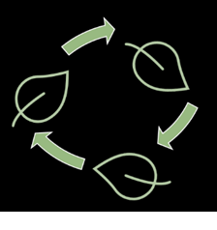**

](#_Details_and_Information)

Reuse

Recycle

Repair

Reduce